Study Guide for Unit 2 Age of Exploration
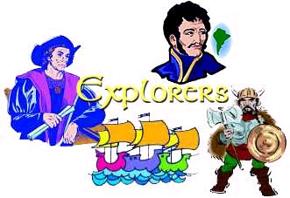
- A goal of the Counter Revolution was to convert people in the new lands to Catholicism.
- Changes that occurred because of exploration of lands in the Americas: Europeans changed the way they thought of the world. It was bigger than they thought and included another big continent, North and South America. Empires in the Americas, like the Incas and Aztecs were conquered by the Europeans.
- Colonists build settlements along rivers or the ocean because it was easier to transport supplies and people using boats.
- Columbus is like an entrepreneur because he made deals to get money for his exploration. He got money from the monarchs in exchange for some of the riches that he found.
- Coronado, Francisco Vazquesz de: explored the American Southwest looking for cities of gold that the Native Americans told him were there. (there are no cities of gold)
- Cortez and Pizarro are similar because they both conquered land and wealth in the Americas. They are different because Cortez conquered the Aztecs and Pizarro conquered the Incas.
- Countries that claimed land in the Americas: Spain, Portugal, England, France, the Netherlands, Sweden and Russia.
- European traders began to travel to Asia by sea because the Ottoman Turks captured Constantinople and blocked trade through the city and because of better navigation technology and ships with better sails.
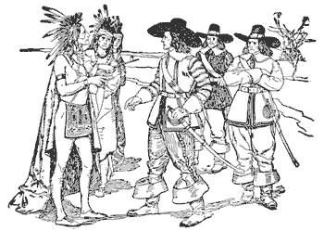
- France: French explored the lands along the St. Lawrence River and south along the Mississippi River. French founded Quebec. They settled in part of present day Canada/
- Goals of European explorations: gaining wealth, controlling new lands, finding new trade routes to Asia, establishing colonies and spreading religious beliefs.
- Magellan’s expedition was the first to go around the globe.
- Marco Polo’s book caused more Europeans to be interested in Asia because he wrote about riches, spice and silks to be found there.
- Northwest Passage is a route through North America by sea. They thought it would be a quicker route to Asia.
- Ponce de Leon explored present day Florida. He was looking (futilely) for the Fountain of Youth. (no cities of gold, no fountain of youth, bummer.)
- Portugal settled eastern South America.
- Present day cities founded by the Dutch are Albany and New York.
- Spain settled most of South America, Central America, the Caribbean, Mexico, Florida and the southwest United States.
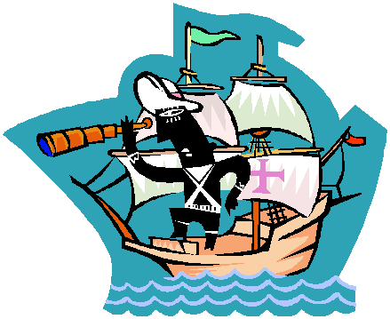
- Travel by Sea changed in the 1400s because of new technologies in navigation like magnetic compasses and the astrolabe. The magnetic compass improved sailing because it told where north was. The astrolabe helped sailors find their location.
- The Triangular Trade was trade routes that carried goods and slaves from Africa, to the colonies in America and England. They linked Europe, African and the Americas. Each continent provided goods that were exchanged for others along the route.
- Vespucci’s accomplishment was that he realized that the Americas were not Asia, but a New World. His first name was Amerigo and America was named for him.
- Words that signal cause and effect: because, since, as a result, when
Words that writers use to compare things: also, like
Words that signal a generalization: often, usually.

